**Exercise 1**

Q1: Write a Python program which accept the radius of a circle from the user and compute the area.

*Sample Output :*   
r = 1.1  
Area = 3.8013271108436504

**Code**

import math

r = float(input("Enter the circle radius : "))

const = math.pi

area = const*r**2

print(area)

Q2: Temperature of a city in Fahrenheit degrees is input through the keyboard. Write a program to convert this temperature into Centigrade degrees.

**Code**

temp = float(input("enter the temperature in ferenhite : "))

degree = 5/9*(temp-32)

print(degree)

Q3: Write a Python Program to make a simple calculator that can add, subtract, multiply and divide

**Code**

def calculator():

    x = float(input("enter the value for n1"))

    y = float(input("enter the value of n2"))

    operator = input("enter the operator : +, -, *, /")

    if operator == "+":

        result = x+y

    elif operator == "-":

        result = x-y

    elif operator == "*":

        result = x*y

    else:

        result = x/y

    print(result)

Q4: Write a Python Program to calculate the square root

**Code**

number = float(input("give me the number "))

square_root = math.sqrt(number)

print(square_root)

Q5: Write a Python Program to Solve the quadratic equation ax**2 + bx + c = 0

# Coeffients a, b and c are provided by the user

[Hint: import complex math module - import cmath]

**Code**

import cmath

a= float(input("enter the value of a "))

b= float(input("enter the value of b "))

c= float(input("enter the value of c "))

base = cmath.sqrt(b**2-4*a*c)

root1 = (-b+base)/2*a

root2 = (-b-base)/2*a

print(root1)

print(root2)

Q6: Write a Python Program to find the area of triangle

# Three sides of the triangle a, b and c are provided by the user

**Code**

a= float(input("enter the value of a "))

b= float(input("enter the value of b "))

c= float(input("enter the value of c "))

s= (a+b+c)/2

area = math.sqrt(s*(s-a)*(s-b)*(s-c))

print(area)

Q7: If a five-digit number is input through the keyboard, write a program to calculate the sum of its digits without using any loop. (Hint: Use the modulus operator ‘%’)

**Code**

number = int(input("enter the 5 digit number "))

a = number%10

b = (number//10)%10

c = (number//100)%10

d = (number//1000)%10

e = (number//10000)%10

Add = a+b+c+d+e

print(Add)

Q8: Write a Python program to print the following string in a specific format

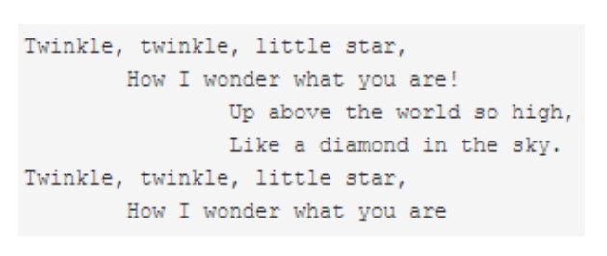

**Code**

string = ''' Twinkle, twinkle, little star,\n \t How I wonder what you are!\n\t Up above the world so high,\n Like a diamond in the sky.\n Twinkle, twinkle, little star,\n\t How I wonder what you are'''

print(string)

Q9: Write a Python program to display your details like name, age, and address in three different lines.

**Code**

profile = (" my name is navanish\n my age is 24\n my address is mumbai")

print(profile)

Q10.Create a string containing both a single quote and  double quote

**Code**

string = "My name is 'Navanish Pandey' and\n\

                my age is '24' "

print(string)

Q11.Create a triple quoted string that contains single and double quotes.

**Code**

string = """ My name is "Navanish Pandey" and

                my age is '24' """

print(string)

Q12.Create a character, then obtain its integer representation.

**Code**

a=input()

b=ord(a)

print(b)

#use char keyword to askey number to char

Q13.Create a single string containing 5 copies of the string 'abc'.

**Code**

string = "abc "*5

print(string)

Q14.Use the multiplication operator to create a "line" of 50 dashes. dashes = '-'*50

**Code**

dashes = '-'*50

print(dashes)

Q15.Convert a string to all upper case.

**Code**

string = "abc"

name = str.upper(string)

name

Q16 : Write a Python program to get a string made of the first 2 and the last 2 chars from a given a string.

**Code**

string = "this is noida"

str1 = string[:2]

str2 = string[-2:]

add = str1+str2

add

Q17: a Python program to get a string from a given string where all occurrences of its first char have been changed to '$', except the first char itself.

Sample String : 'restart'  
Expected Result : 'resta$t'

**Code**

string = "restart"

b = list(string)

b[5]= "$"

b = "".join(b)

b

Q18: Write a Python program to get a single string from two given strings, separated by a space and swap the first two characters of each string.

Sample String : 'abc', 'xyz'   
Expected Result : 'xyc abz'

**Code**

string = ('abc', 'xyz')

a = list(string)

b = list(a[0])

c = list(a[1])

c[2],b[2]=b[2],c[2]

print("".join(c) + " " + "".join(b))

#OR

string1 = "abc"

string2 = "xyz"

print(string2[0:2]+string1[-1]+ " " + string1[0:2]+string2[-1])